

Make a Movie Camp

Week of June 20 - 1PM to 4PM

### Overview

The Tech Em Studios Make a Movie camp is a four day (twelve hour) camp that seeks to educate students on the process of movie making. In this camp, students will exercise the art of making a movie. Students start by creating their own idea for a movie. Using iMovie and Garageband, they will make their idea come to life by expanding their idea to a script and storyboard. Campers will have their movie come to life by acting out scenes, creating animations and special effects, filming and editing.

### Outline

* Development: Defining goals, creating optional work groups, idea development, and script development.
* Pre-production: Creating a storyline, setting-up locations, and development and gathering of necessary items (equipment, props, costumes, etc.).
* Production: The process of filming.
* Post-Production: Editing, screening, and exporting the product to the distribution medium.
* Distribution: Setting up a premiere & evaluating the project.

### Performance Objectives

*Students will be able to-*

* Create a final movie project individually or with a team.
* Learn and implement widely used movie-making processes such as, idea and script development, storyboarding, filming, editing, project exporting, premiere setup.
* Actively practice skills involved in critical thinking, problem-solving, and collaboration.

**Materials:**

iPads (iMovie & Garageband)

Whiteboard(s)

Dry erase markers

Storyboard Sheets -need to make these; something like:



to look something like this:

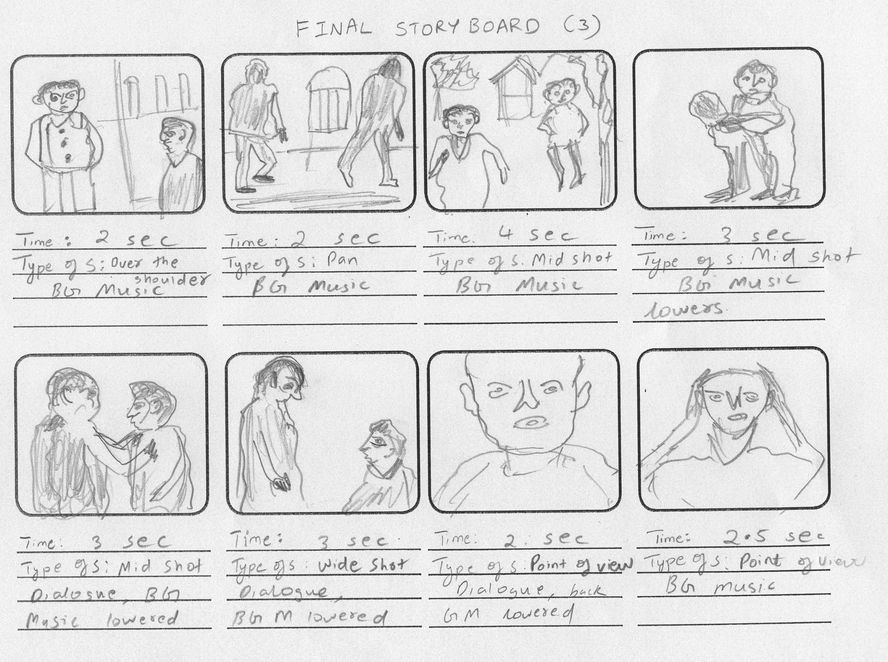

### PROCEDURE:

### Day 1

**Main Ideas:**

* Brainstorm to Idea
* Idea to Script (story)
* Script to Storyboard

**Objectives:**

* Understand the schedule and timeline
* Come up with at least three ideas for a movie
* Write basics of story and its dialogue (if any)
* Have a finished or almost finished storyboard

**Icebreaker:** Introduce students and instructors/interns; age, name, any experience with any movie making or garage band.

* Outline objectives for the camp
* Go over timeline/schedule to be referred to throughout the week
* Go over Make a Movie Camp slides
  + Go through until Storyboard slide

Brainstorm to idea:

* Come up with at least three movie ideas
  + Settle on one with help of instructors/interns

Idea to Script:

* Develop a script for the movie idea
* This helps to make the video make sense
* Like creating the story
* Keep in mind the general premises of a story: a protagonist saves the day from an antagonist or goes on a journey.

Script to Storyboard:

* Make the story come to life by drawing out scenes from the story
* Optional but helpful to have times specified for each scene

### Day 2

**Main Ideas:**

* Storyboard to Film
* Day of filming

**Objectives:**

* Have a finished storyboard
* Have several filmed scenes

Script to Storyboard:

* Finish up storyboard scenes

Storyboard to Film:

* Bring movie idea, script and storyboard to life by filming scenes referencing storyboard
* Start gathering materials ((some from home?) think about material the day before?)
* Start filming each scene with iPads
  + Incorporate use of lighting and view angles

### Day 3

**Main Ideas:**

* Film to Edit to more film and edit

**Objectives:**

* Have all scenes filmed
* Start on editing the film using iMovie
  + Work audio into scenes using Garageband

Film to Edit:

* Finish up filming last scenes
* Start work on transitioning
  + Fluidity of going from one scene to the next
* Work in audio and special effects
* Re film some scenes or add a couple more scenes

### Day 4 (Final Day)

Main Ideas: Edit to Screening/Showing

Objectives:

* Have a finished edited film
* Have a showing for the movie project

Edit To Screening/Showing:

* Finish up final edits
* Get set up ready for showing
* Determine exporting options

### Evaluation:

* Did the students meet your objectives?
* Did the lesson accommodate all of your learners?
* What were the strengths and weaknesses of the lessons?
* If you were to use this lesson again, what would you change?

iPad Numbers:

Emerson - #16

Lexi - #18

Kaysian - Own

Henly - Own

Sammy - #2

Lousia - Own

Scarlett - #12

Groups:

#1: Emerson [Comedy/Action]

#2: Henly, Kaysian, Sammy [Scary/Comedy]

#3: Scarlett, Lexi, Louisa [Horror Movie]

 TechEmStudios.com

(804)-476-0278